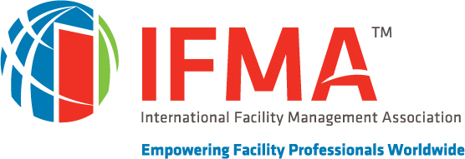
<Community Name> Community of Practice

Dear <Name>:

IFMA is the recognized authority on facility management, providing resources and benefits that help FMs advance their careers and improve the performance of their facilities. As a global source of professional opportunities and support, the <community name> Community brings targeted source of <community interest> facility management education, information and interaction.

Your <community acronym> membership is up for renewal on <community PTD>. Will you continue to strengthen your knowledge and skills to advance your professional career by renewing your <community acronym> membership?

Renewing your membership is easy!
- Renew by phone at +1-713-623-4362
It is our goal to provide you with opportunities that enrich your career objectives, business relationships and personal friendships. I encourage you to renew your annual community membership today to ensure that you continue benefiting from the educational, informational and networking resources available through the <community acronym> community.
The Value of Belonging
- Community members connect with like-minded individuals from around the world who share knowledge, answers and insights about managing <community industry> facility types or business sectors facilities.
- Participate in discussion groups to solve job-related problems and assist fellow members with projects and career objectives through the <community> online community.
- Access news, case studies, educational programs, benchmarking and best practices to address specific issues that you face managing <community industry> facilities.
- Keep current on the latest practices, trends and technologies relative to your industry or work environment.
- Community members benefit from professional and personal development.

If you have any questions or comments about your community membership, please contact me. We want to ensure that we continue to be of value to you.

Thank you for being a valued IFMA member and supporter of the <<community name>> Community. We look forward to serving you for years to come.

Sincerely,
<signature if available>

President
IFMA <Community Name> Community of Practice

